Q1)
Write a Python program that reads a text file named 'quotes.txt' containing famous quotes, each on a separate line. Your program should perform the following tasks:
- Read the 'quotes.txt' file and display the total number of quotes.
- Prompt the user to enter a keyword.
- Search for quotes containing the provided keyword and display those quotes.

Code:
with open('quotes.txt') as f:
quotes = [q.strip() for q in f if q.strip()]
print("Total quotes:", len(quotes))
keyword = input("Enter keyword: ").lower()
print('\n'.join(q for q in quotes if keyword in q.lower()))

Q2)
Question: Matrix Operations
You are working on a project that involves analyzing data represented as matrices. Using NumPy, perform the following tasks:
- Create a NumPy array representing a 3x3 matrix named "matrix_A" with random integer values ranging from 1 to 10.
- Create another NumPy array representing a 3x3 identity matrix named "identity_matrix".
- Perform element-wise multiplication of "matrix_A" and "identity_matrix" and store the result in a new NumPy array named "result_matrix".
- Calculate the sum of all elements in "result_matrix" and print the result.
- Using slice notation, print the 2x2 sub-matrix that includes elements from rows up to and including row # 1 and all columns after and including column 1.
Code:

import numpy as np
matrixA = np.random.randint(1, 11, (3, 3))
identity = np.eye(3, dtype=int)
result = np.multiply(matrixA, identity)
print("Sum of elements:", result.sum())
print("2x2 sub-matrix:\n", result[:2, 1:])

Q3)
You are managing the inventory for an e-commerce platform that sells various products. Your task is to perform analysis on the product inventory dataset to derive insights for better inventory management. You have been provided with a dataset named "inventory_data.csv", which contains the following columns:
- ProductID: Unique identifier for each product.
- ProductName: Name of the product.
- Category: Category of the product (e.g., electronics, clothing, accessories).
- Quantity: Quantity of the product available in the inventory.
- Price: Price of the product per unit.
Your task is to write Python code using Pandas and Numpy to perform the following tasks:
- Load the dataset into a Pandas DataFrame.
- Explore the data and perform any necessary data cleaning or preprocessing.
- Calculate and display the total inventory value for each category (Quantity * Price).
- Identify the top-selling product category based on the total quantity sold.
- Determine the average price of products within each category.
- Analyze the inventory to identify any products that are low in stock (quantity below a certain threshold, e.g., 10 units) and need to be restocked.

Code:
import pandas as pd
df = pd.read_csv('inventorydata.csv')
df['InventoryValue'] = df['Quantity'] * df['Price']
print("Total inventory value per category:\n", df.groupby('Category')['InventoryValue'].sum())

print("Top-selling category:", df.groupby('Category')['Quantity'].sum().idxmax())
print("Average price per category:\n", df.groupby('Category')['Price'].mean())
print("Low stock products:\n", df[df['Quantity'] < 10][['ProductID', 'ProductName', 'Quantity']])

Q4)
You are given a dataset containing the monthly sales performance for three products (product_A, product_B, product_C) across four regions (North, South, East, West) over the past two years. The dataset includes columns: month, region, product_A_sales, product_B_sales, and product_C_sales.
- Using Matplotlib, write Python code to create a line chart showing the monthly sales trends for product_A and product_B in the North region over the two years. Ensure that the axes are labeled, a legend is included, and the individual data points are marked.

- Create a histogram that visualizes the distribution of monthly sales for product_C across all regions. Write the Python code and describe how adjusting the number of bins could change the visualization's interpretation.

- You want to compare sales of all three products across the four regions. Write Python code to create a stacked bar chart that shows the total monthly sales for all products by region.

- Generate a scatter plot that visualizes the relationship between product_A_sales and product_B_sales across all regions. Use color coding to differentiate between regions and explain how this plot can help reveal correlations between the sales of the two products.

Code:
import pandas as pd
import matplotlib.pyplot as plt
df = pd.read_csv('sales_data.csv')
# 1. Line chart (North region)
north = df[df['region'] == 'North']
ax = north.plot(x='month', y=['productA_sales', 'productB_sales'], marker='o')
ax.set_ylabel('Sales'); plt.legend(['A', 'B']); plt.show()
# 2. Histogram (productC sales)
df['productC_sales'].plot.hist(bins=10)
plt.xlabel('Product C Sales'); plt.show()
# More bins = finer detail; less bins = broader view
# 3. Stacked bar chart (sales by region)
df.groupby('region')[['productA_sales', 'productB_sales', 'productC_sales']].sum().plot.bar(stacked=True)
plt.ylabel('Sales'); plt.show()
# 4. Scatterplot (A vs B sales, by region)
colors = dict(zip(df['region'].unique(), ['r', 'b', 'g', 'm']))
df.plot.scatter(x='productA_sales', y='productB_sales', c=df['region'].map(colors))
plt.legend(colors); plt.show()

Q5)
You are tasked with scraping a list of recent movies along with their release dates, ratings, and genres from a hypothetical webpage containing movie information.
Below is the HTML content of the webpage:
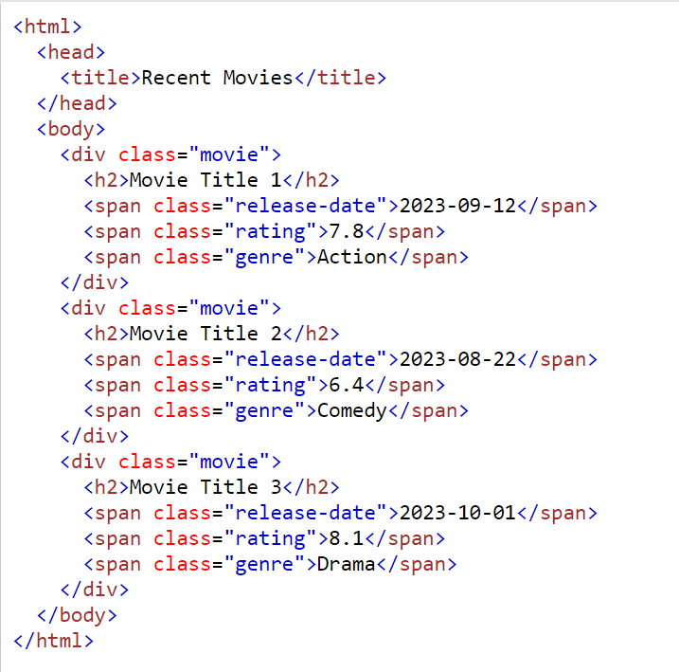

- Write Python code using the requests module to send a GET request to the page. Ensure that you handle potential connection errors.

- Using BeautifulSoup from the bs4 module, parse the HTML content and extract the movie titles, release dates, ratings, and genres. Write Python code to achieve this.

- Organize the extracted data into a Pandas DataFrame with columns: Title, Release Date, Rating, and Genre. Write the Python code to create this DataFrame and display the resulting data.

- Once the data is in the DataFrame, filter out movies with a rating below 7.0. Write Python code to perform this operation and display the filtered DataFrame.

- Finally, save the dataframe to a csv file for later use.

Code:
import requests
from bs4 import BeautifulSoup
import pandas as pd
url = 'http://example.com/movies'
try:
response = requests.get(url, timeout=5)
response.raise_for_status()
except Exception as e:
print("Error:", e)
soup = BeautifulSoup(response.text, 'html.parser')
rows = [(m.find('span', class_='title').get_text(strip=True),
m.find('span', class_='release_date').get_text(strip=True),
float(m.find('span', class_='rating').get_text(strip=True)),
m.find('span', class_='genre').get_text(strip=True))
for m in soup.select('div.movie')]
df = pd.DataFrame(rows, columns=['Title', 'Release Date', 'Rating', 'Genre'])
print(df[df['Rating'] >= 7.0])
df[df['Rating'] >= 7.0].to_csv('filtered_movies.csv', index=False)

